**Gesture Detection of Sign Language Using Machine Learning**

Heet Shah (2021A7PS0125U)

and

Arjun Nadar (2021A7PS0062U)

**ABSTRACT**

This report explores the development and implementation of a Machine Learning (ML) model aimed at Hand Gesture Recognition in the context of Sign Language Interpretation. The model's architecture integrates cutting-edge techniques from computer vision, specifically leveraging the MediaPipe library and ensemble learning methodologies. Its primary goal is to accurately interpret and understand hand gestures captured through image data, facilitating seamless communication for individuals reliant on sign language. The report encompasses the complete lifecycle of the model, including data collection, preprocessing techniques, model development, training methodologies, evaluation metrics, and deployment strategies.

Key aspects covered in this report include discussions on data collection and preprocessing, detailing the model architecture utilizing MediaPipe for hand landmark detection, elucidating the ensemble learning algorithms applied for classification, and providing an in-depth analysis of the model's training and evaluation phases. Additionally, the report highlights the creation of a user-friendly graphical interface using Tkinter and OpenCV, enabling real-time gesture recognition and image-based predictions.

Through this work, the report aims to underscore the model's significance in addressing communication barriers for individuals with hearing impairments or those immersed in sign language-based communication environments. It emphasizes the model's accuracy, efficiency, and potential impact in enhancing communication experiences for users engaged in sign language interactions.

**Key Words -** Gesture Recognition, Sign Language, Machine Learning

**INTRODUCTION**

Gesture recognition, a burgeoning field within machine learning and computer vision, has garnered immense interest due to its potential to bridge communication gaps, particularly for individuals reliant on sign language as their primary mode of communication. This report delves into the development and implementation of a sophisticated Machine Learning (ML) model tailored for Hand Gesture Recognition in Sign Language Interpretation. Leveraging cutting-edge techniques in computer vision, this model integrates the MediaPipe library and ensemble learning methodologies to accurately interpret and understand hand gestures captured through image data.

The primary objective of this project is to construct an efficient system capable of recognizing and interpreting hand gestures associated with sign language. This system aims to facilitate seamless communication for individuals with hearing impairments or those engaged in sign language-based communication environments. The report encapsulates the entire lifecycle of the Hand Gesture Recognition Model, encompassing data collection, preprocessing, model development, training, evaluation, and deployment. It also delves into the development of a user-friendly graphical interface using Tkinter and OpenCV, enabling real-time gesture recognition and image-based predictions.

Throughout the report, critical components of the Hand Gesture Recognition Model are elucidated. This encompasses discussions around data collection and preprocessing methodologies, insights into the model architecture leveraging MediaPipe for hand landmark detection, a description of ensemble learning algorithms utilized for classification, and a detailed overview of the model training and evaluation phases. Furthermore, it sheds light on the graphical user interface designed to facilitate interaction with the model for real-time gesture recognition and image-based predictions.

In conclusion, this report presents a comprehensive exploration of the Hand Gesture Recognition Model tailored for sign language interpretation. It emphasizes the model's accuracy, efficiency, and potential impact in enhancing communication for individuals engaged in sign language-based interactions.

**LITERATURE SURVEY**

The amalgamation of research in hand gesture recognition and sign language understanding encompasses a diverse array of methodologies, each contributing significantly to advancing this field.

Techniques employed in this body of research include traditional image processing methods and cutting-edge machine learning and deep learning approaches. Traditional methods encompass skin color identification, background reduction, and clustering algorithms, aiming to accurately detect and segment hand regions despite various environmental challenges. On the other hand, advanced techniques like Histogram of Oriented Gradients (HOG), Principal Component Analysis (PCA), Local Binary Patterns (LBP), and Convolutional Neural Networks (CNN) focus on feature extraction and classification, providing robustness and accuracy in recognizing and interpreting hand gestures.

These studies address several challenges inherent in gesture recognition. Issues related to illumination, noise, detection, and segmentation difficulties are particularly highlighted. Researchers strive to improve accuracy by refining models to better identify specific gestures and sign language characters, especially under varied environmental conditions and in real-time scenarios.

The applications of these advancements are vast and impactful. Gesture recognition technology significantly enhances human-computer interaction, offering a more natural and intuitive means of interfacing with devices and applications. Furthermore, in the context of sign language, these technologies bridge communication gaps, translating sign language into text or spoken language and enabling seamless interaction between individuals with hearing impairments and others.

The exploration of future directions and opportunities remains a central focus. Researchers seek to augment datasets to enhance model performance and adaptability across diverse scenarios. There is a continuous quest to refine existing algorithms while exploring novel methodologies to further enhance accuracy and accessibility. Moreover, the potential for applying gesture recognition across various industries, such as healthcare, automotive, and education, continues to be a subject of exploration and development.

Collectively, this comprehensive body of literature signifies the evolving landscape of research, striving for more accurate, adaptable, and impactful hand gesture recognition and sign language understanding technologies, with far-reaching implications for numerous real-world applications and accessibility domains.

**IMPLEMENTATION**

This report explores a hand gesture recognition application, detailing its functionalities and future potential. The application boasts four pre-trained models capable of deciphering American Sign Language (ASL) alphabets and digits, along with Indian Sign Language (ISL) digits. Users can interact with the application via either a real-time video feed or by uploading pre-captured images.

In the live feed mode, the application leverages OpenCV for computer vision and MediaPipe for hand pose estimation, extracting key landmarks from the continuous video stream. These landmarks serve as the basis for feature extraction, which feeds into the chosen pre-trained model. Depending on the user's selection, the application can utilize models trained on online datasets for ASL alphabets, ASL digits, or ISL digits, or a self-made model specifically for ASL alphabets. Upon analyzing the extracted features, the chosen model predicts the corresponding hand gesture, displaying the interpreted letter or digit in real-time on the user interface.

|  |  |  |  |  |
| --- | --- | --- | --- | --- |
|  | **Size** | **No. of Classes** | **Samples per Classes** | **Test Size** |
| ASL Alphabet | 78,000 | 26 | 3000 | 20% |
| ISL Digits | 3300 | 10 | <=300 | 20% |
| ASL Digit | 5000 | 10 | 500 | 20% |
| ASL(Trained on my hands) | 13,000 | 26 | 500 | 20% |

For users who prefer analyzing pre-captured images, the upload image mode offers a convenient alternative. Users can upload an image containing a hand gesture, triggering a similar process as the live feed. OpenCV facilitates reading the uploaded image, while MediaPipe assists with hand landmark detection. Subsequently, the chosen model, based on user selection, analyzes the extracted features and predicts the corresponding hand gesture, updating the user interface with the interpreted letter or digit and the processed image for confirmation.

The application utilizes a powerful combination of libraries, including OpenCV, MediaPipe, NumPy, pickle, Joblib, Tkinter, and PIL, to achieve its functionalities. OpenCV handles computer vision tasks, MediaPipe ensures accurate hand pose estimation, NumPy facilitates efficient numerical computations, pickle, and Joblib assist with model serialization and loading, Tkinter creates the user interface, and PIL contributes to image processing.

Model Architecture and Development: We used the MediaPipe library for accurate hand landmark detection and ensemble learning methodologies to create a model that can classify hand landmarks into their corresponding sign language gestures. The ASL Alphabet dataset, ISL Digits dataset, American Sign Language Digit Dataset, and the personalized dataset were all used to train the model. All training iterations were completed within a single epoch. This model was trained on just a single epoch across all datasets

Graphical User Interface (GUI) Development: Simultaneously with model development, a user-friendly graphical interface was designed using the Tkinter library and OpenCV. This interface facilitated real-time interaction with the trained model, enabling intuitive visualization of gesture recognition results and predictions.

**ARCHITECTURE DIAGRAM**

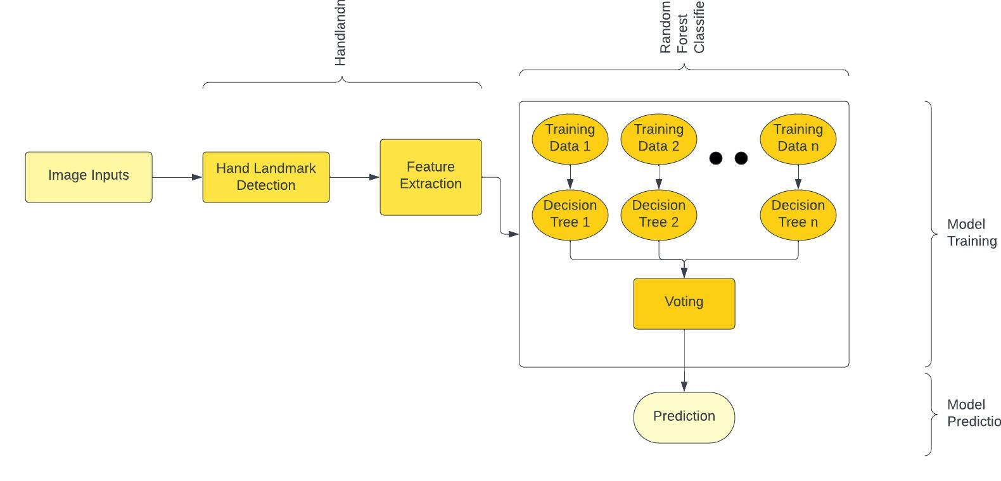

**ALGORITHM**

The Hand Gesture Recognition Model relies primarily on an ensemble learning technique known as the RandomForestClassifier. This algorithm amalgamates numerous decision trees, each contributing to the final prediction regarding the displayed hand gesture in an image. Ensemble learning, as demonstrated by RandomForestClassifier, harnesses the collective intelligence of individual decision trees to improve accuracy and robustness in classification tasks.

One of the striking features of the RandomForestClassifier lies in its adaptability to heterogeneous datasets. In the case of this model, it amalgamates data from diverse sources, including the ASL Alphabet dataset, the Indian Sign Language Digits dataset, the American Sign Language Digit Dataset, and a personalized dataset based on specific hand gestures. What's noteworthy is the model's ability to converge these distinct datasets into a cohesive framework for training, effectively learning from various sources in a singular epoch, thereby accelerating the learning process significantly.

Acting as a meta-estimator, the RandomForestClassifier organizes these individual decision trees, allocating subsets of the hand gesture data for analysis. Through this collaborative effort, the ensemble of decision trees collectively evaluates and consolidates their findings to make a final inference on the presented hand sign. Importantly, the algorithm doesn’t simply memorize specific hand gestures encountered during training but instead identifies underlying patterns and features inherent in different hand signs. This enables the model to generalize and recognize previously unseen hand gestures based on learned rules and discernable characteristics.

**RESULTS AND DISCUSSION**

The Hand Gesture Recognition Model did well in recognizing different hand signs from various datasets. It achieved high accuracy levels across different sets of hand gestures like the ASL Alphabet, Indian Sign Language Digits, American Sign Language Digits, and a personalized set of hand gestures. For instance, it got around 97.30% accuracy for the ASL Alphabet, 99.77% for Indian Sign Language Digits, 99.32% for American Sign Language Digits, and 98.68% for the personalized set. What's impressive is that it learned all this in just one attempt, showing it can learn pretty fast.

These high accuracy scores demonstrate the model's effectiveness in recognizing hand gestures. However, it's also essential to check if there are any biases or limitations in the data or model. By adding more diverse hand signs or continuously teaching the model, it might become even better at recognizing a wider range of hand gestures.

|  |  |
| --- | --- |
| **Datasets** | **Accuracies** |
| ASL Alphabet | 97.30% |
| ISL Digits | 99.77% |
| ASL Digit | 99.31% |
| ASL(Trained on my hands) | 98.68% |

**SCREENSHOTS OF GUI**

**Live Feed Section**

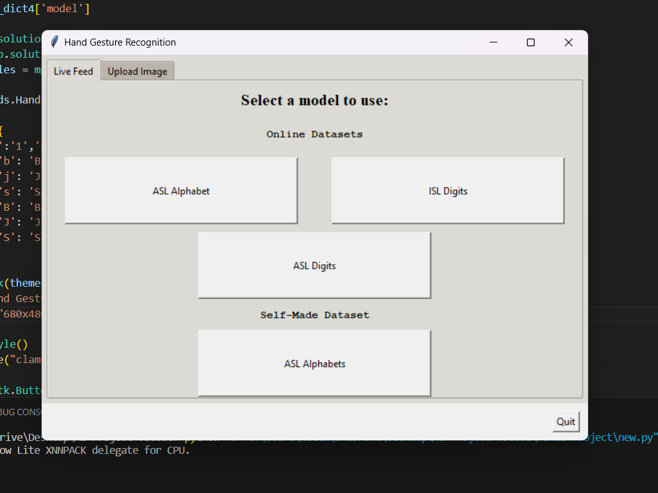

**Upload Image Section**

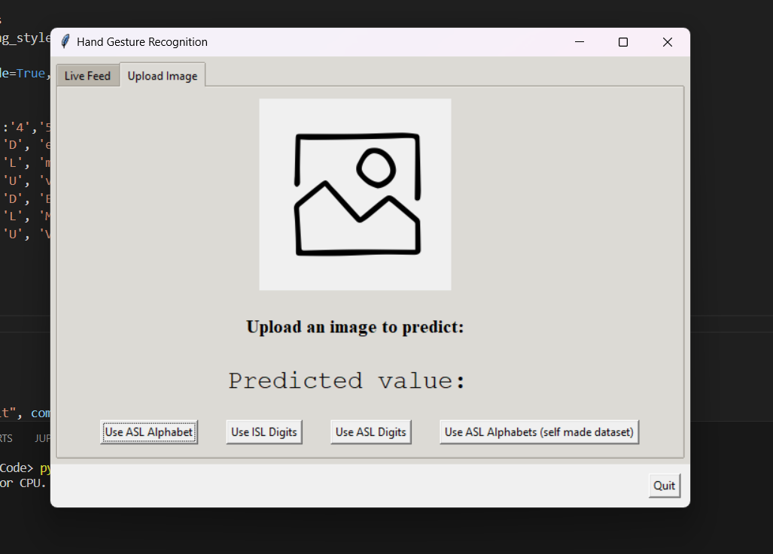

**Running Using Live Feed**

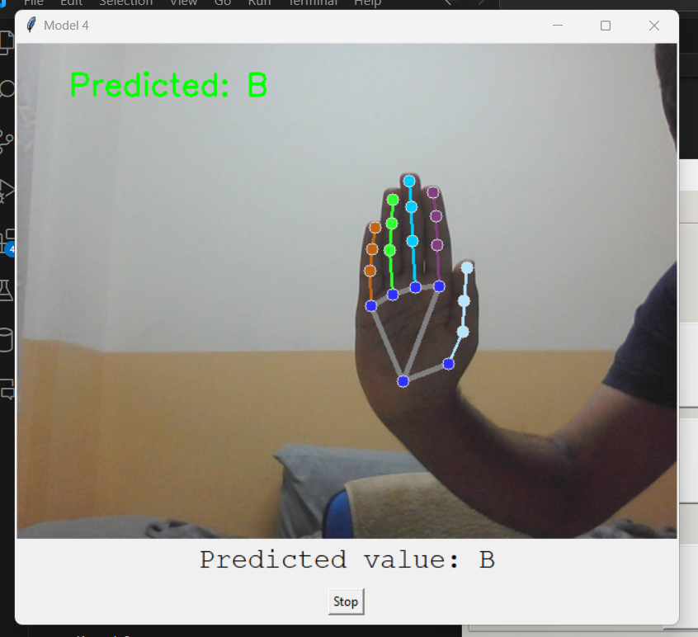

**Running Through Uploading the Image**

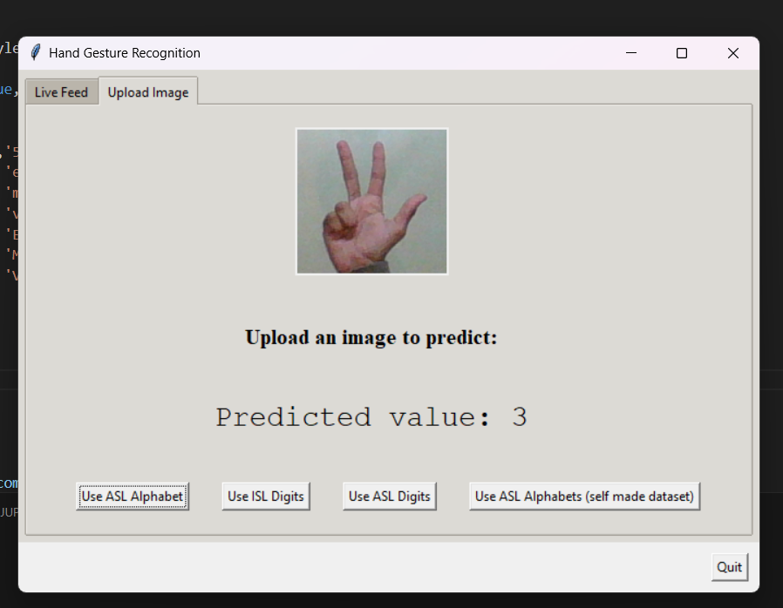

**FLOW CHART**

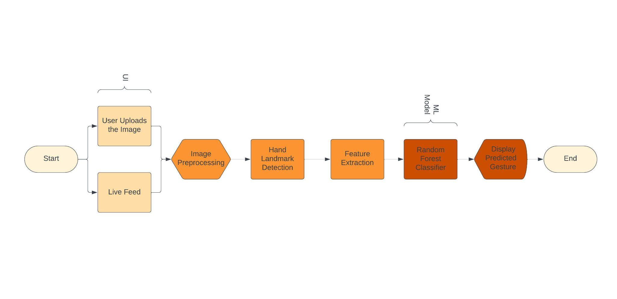

**CONCLUSION**

In conclusion, the Hand Gesture Recognition Model has shown promising capabilities in identifying and interpreting various hand signs across multiple datasets. Leveraging ensemble learning, particularly the RandomForestClassifier, the model has demonstrated its ability to comprehend and categorize diverse hand gestures.

The model's proficiency in generalizing to previously unseen hand signs implies a comprehensive understanding of underlying patterns and features inherent in different hand gestures. While the model exhibits robustness and adaptability, a comprehensive exploration into potential biases or limitations within the datasets and model architecture could provide valuable insights for further enhancements.

Overall, the Hand Gesture Recognition Model presents a solid foundation for applications requiring accurate hand gesture recognition. It underscores the potential of machine learning algorithms in interpreting hand gestures, offering possibilities for future developments and refinements in this domain.

**DATASETS**

1. ASL Alphabet - <https://www.kaggle.com/datasets/grassknoted/asl-alphabet/data>
2. ISL Digits - <https://www.kaggle.com/datasets/kartik2112/indian-sign-language-translation-letters-n-digits/data>
3. ASL Digit - <https://www.kaggle.com/datasets/rayeed045/american-sign-language-digit-dataset>

**REFERENCES**

1. Jana, Ayanabha & Krishnakumar, Shridevi. (2022). Sign Language Gesture Recognition with Convolutional-Type Features on Ensemble Classifiers and Hybrid Artificial Neural Network. Applied Sciences. 12. 7303. 10.3390/app12147303.
2. Divyashree B A, Manjushree K. "Image Processing Techniques for Hand Gesture and Sign Recognition." International Research Journal of Engineering and Technology (IRJET) 6.01 (2019): 1588-1593.
3. Sharma, A., Mittal, A., Singh, S., & Awatramani, V. (2020). Hand Gesture Recognition using Image Processing and Feature Extraction Techniques. Procedia Computer Science, 173, 181-190. <https://doi.org/10.1016/j.procs.2020.06.022>.
4. G. A. Rao, K. Syamala, P. V. V. Kishore and A. S. C. S. Sastry, "Deep convolutional neural networks for sign language recognition," 2018 Conference on Signal Processing And Communication Engineering Systems (SPACES), Vijayawada, India, 2018, pp. 194-197, doi: 10.1109/SPACES.2018.8316344.
5. H. -Y. Chung, Y. -L. Chung and W. -F. Tsai, "An Efficient Hand Gesture Recognition System Based on Deep CNN," 2019 IEEE International Conference on Industrial Technology (ICIT), Melbourne, VIC, Australia, 2019, pp. 853-858, doi: 10.1109/ICIT.2019.8755038.
6. P S, Dr-Neethu & Ramadass, Suguna & Sathish, Divya. (2020). An efficient method for human hand gesture detection and recognition using deep learning convolutional neural networks. Soft Computing. 24. 10.1007/s00500-020-04860-5.
7. X. Jiang and W. Ahmad, "Hand Gesture Detection Based Real-Time American Sign Language Letters Recognition using Support Vector Machine," 2019 IEEE Intl Conf on Dependable, Autonomic and Secure Computing, Intl Conf on Pervasive Intelligence and Computing, Intl Conf on Cloud and Big Data Computing, Intl Conf on Cyber Science and Technology Congress (DASC/PiCom/CBDCom/CyberSciTech), Fukuoka, Japan, 2019, pp. 380-385, doi: 10.1109/DASC/PiCom/CBDCom/CyberSciTech.2019.00078.
8. Han, et al. (2022). Development and Application of Hand Gesture Recognition System for Early Childhood Education Using MediaPipe. Journal of System and Management Sciences, 12(2), 462-476.*
9. K. Roy, A. Mohanty and R. R. Sahay, "Deep Learning Based Hand Detection in Cluttered Environment Using Skin Segmentation," 2017 IEEE International Conference on Computer Vision Workshops (ICCVW), Venice, Italy, 2017, pp. 640-649, doi: 10.1109/ICCVW.2017.81.
10. B., Abhishek & Krishi, Kanya & M., Meghana & Daaniyaal, Mohammed & S., Anupama. (2020). Hand gesture recognition using machine learning algorithms. Computer Science and Information Technologies. 1. 116-120. 10.11591/csit.v1i3.p116-120.
11. P. Zhao, "A Review on Machine Learning and Gesture Recognition," 2020 International Conference on Computing and Data Science (CDS), Stanford, CA, USA, 2020, pp. 425-428, doi: 10.1109/CDS49703.2020.00089.
12. K. Amrutha and P. Prabu, "ML Based Sign Language Recognition System," 2021 International Conference on Innovative Trends in Information Technology (ICITIIT), Kottayam, India, 2021, pp. 1-6, doi: 10.1109/ICITIIT51526.2021.9399594.
13. N. Rajasekhar, M. G. Yadav, C. Vedantam, K. Pellakuru and C. Navapete, "Sign Language Recognition using Machine Learning Algorithm," 2023 International Conference on Sustainable Computing and Smart Systems (ICSCSS), Coimbatore, India, 2023, pp. 303-306, doi: 10.1109/ICSCSS57650.2023.10169820.
14. Singh, S. (n.d.). *Hand Gesture Recognition using ML Algorithms*. www.linkedin.com. https://www.linkedin.com/pulse/hand-gesture-recognition-using-ml-algorithms-sreeshti-singh/
15. Mmcoe, G. (2023, January 25). Hand gesture recognition using Machine Learning - GDSC MMCOE - Medium. Medium. <https://medium.com/@gdsc_32043/hand-gesture-recognition-using-machine-learnign-a92b5a456374>
16. I. (2023, August 17). *Hand Tracking and Gesture Recognition Using AI: Applications and Challenges*. Intellias. https://intellias.com/hand-tracking-and-gesture-recognition-using-ai-applications-and-challenges/